Module 5: Critical Thinking

Part 1:
Write a program that uses nested loops to collect data and calculate the average rainfall over a period of years. The program should first ask for the number of years. The outer loop will iterate once for each year. The inner loop will iterate twelve times, once for each month. Each iteration of the inner loop will ask the user for the inches of rainfall for that month. After all iterations, the program should display the number of months, the total inches of rainfall, and the average rainfall per month for the entire period.

Source Code

# import calendar month names
import calendar

#string for month names from calendar
list_of_months = list(calendar.month_name)[1:]

print("Let's calculate the average rainfall for a period of years")

#number of years to be calculated
num_Year = int(input('Enter the number of years? '))

#initial values for total rainfall and months to 0
total_Ranifall = 0.0
total_Months = 0

for i in range(0, num_Year):

for j in range(0, 12):
total_Months += 1
print("Enter the amount of rainfall for", list_of_months[j], "in year", i+1)
total_Ranifall = total_Ranifall + float(input())

print("Total number of months is: ", total_Months)
print("Total amount of rainfall is ","{:.2f}".format(total_Ranifall))
print("The average rainfal per month is:", "{:.2f}".format(total_Ranifall/total_Months))

Screen Shot in VSCode:
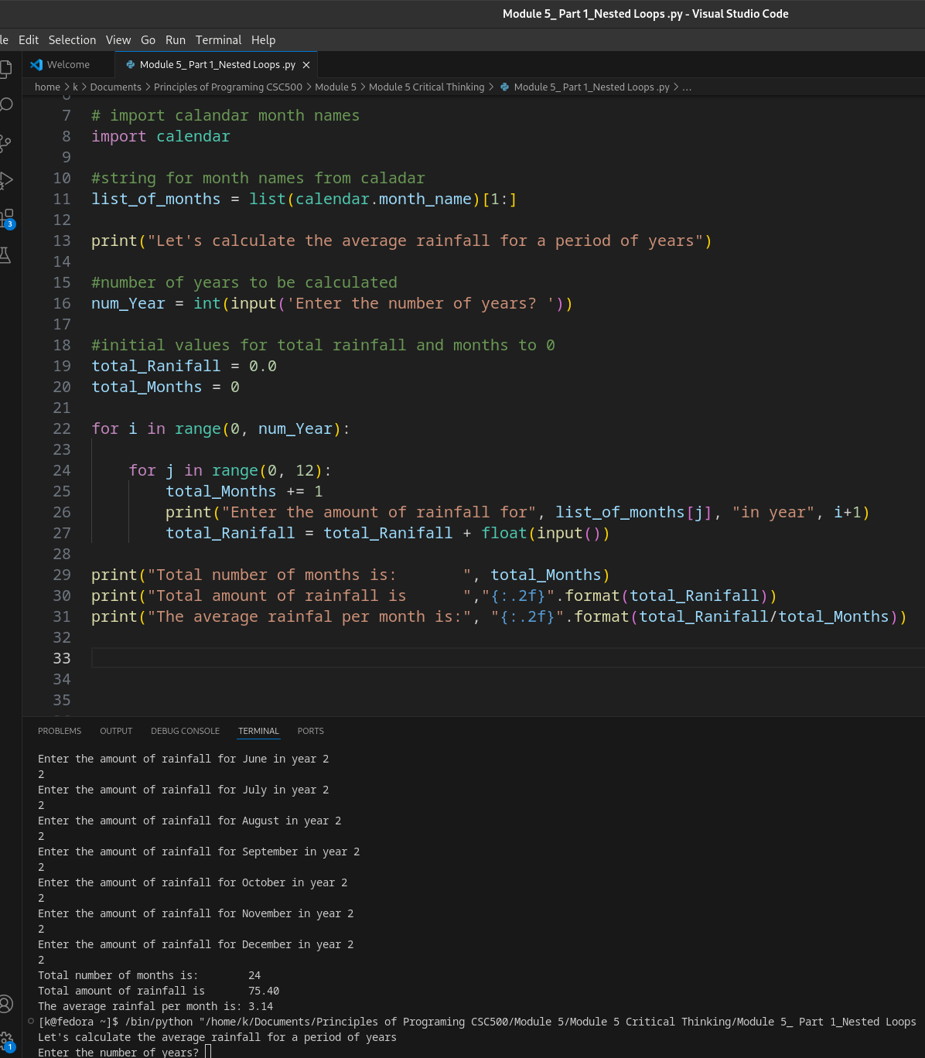

GitHub link:

Part 2:
The CSU Global Bookstore has a book club that awards points to its students based on the number of books purchased each month. The points are awarded as follows:
- If a customer purchases 0 books, they earn 0 points.
- If a customer purchases 2 books, they earn 5 points.
- If a customer purchases 4 books, they earn 15 points.
- If a customer purchases 6 books, they earn 30 points.
- If a customer purchases 8 or more books, they earn 60 points.
Write a program that asks the user to enter the number of books that they have purchased this month and then display the number of points awarded.
Source Code:

customer_Points = 0 #Customer Points
customer_Books = 0.0 #Number of books being purchased
control = True #Control variable for while loop initially True, False to exit while

while control is True: #while loop until control is False
try:
#is customer_Books and integer
customer_Books = int(input("Hello! How many books have you purchased this month? "))

#when input is not an integer
except ValueError:
print("Opps! That was an invalid entry. Try again.")

else:
#customer_Books is a valid number, control = False to exit while
control = False

if customer_Books < 2:
customer_Points = 0

if customer_Books >= 2 and customer_Books < 4:
customer_Points = 5

if customer_Books >= 4 and customer_Books < 6:
customer_Points = 15

if customer_Books >= 6 and customer_Books < 8:
customer_Points = 30

if customer_Books >= 8:
customer_Points = 60

print("You have earned", customer_Points, "points this month.")
Screen Shot in VSCode:
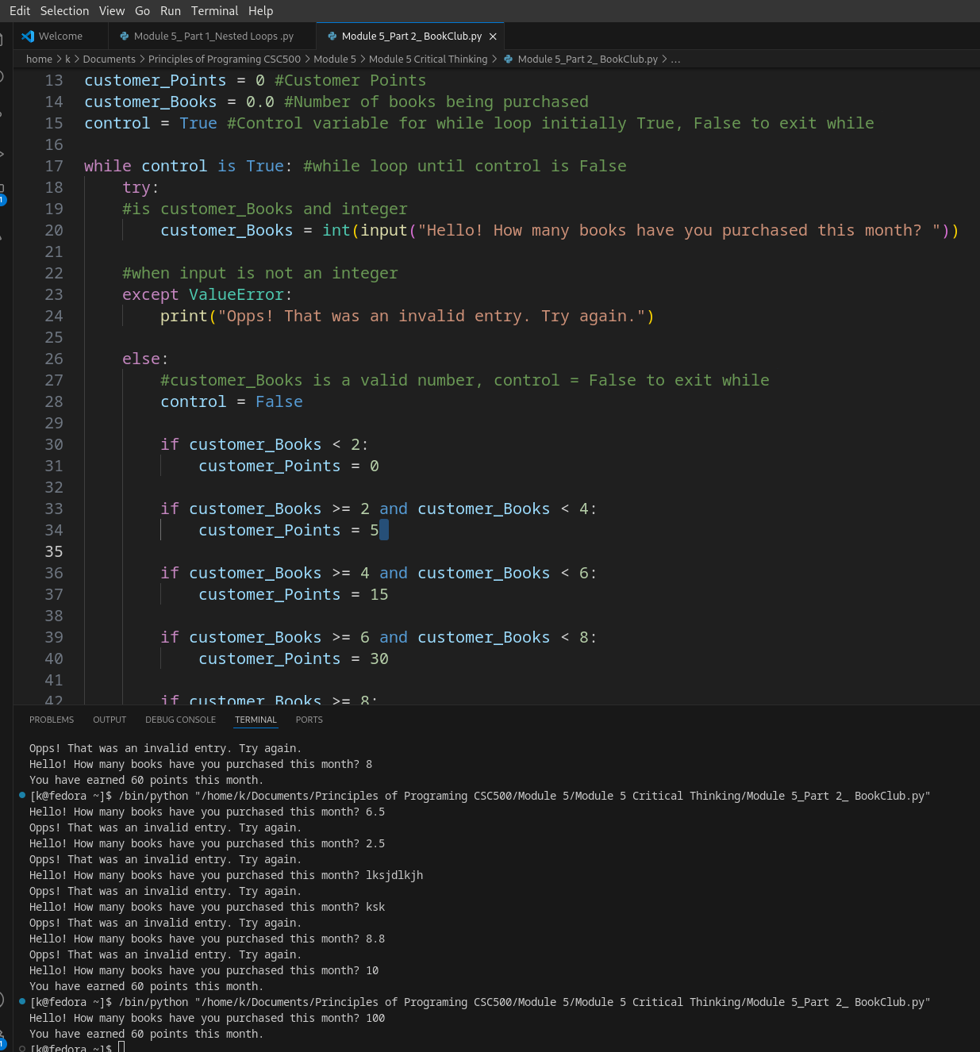
GitHub link:

Submission:
Compile and submit your pseudocode, source code, and screenshots of the application executing the code from Parts 1 and 2, the results and GIT repository in a single document (Word is preferred).

